DNM: General Mandate 2018
On 08 Jun 2018, DANAMECO Medical Joint Stock Corporation announced the General Mandate 2018 as follows:
Article 1: Approve report of Board of Directors on operation results of Board of Directors in 2017
Article 2: Approve report of Management Board on the operation situation and investment in 2017 and plan on investment and business in 2018 as follows:
In 2017:
(i) Total revenue from sale of goods and services: 171.4 billion dongs
(ii) Profit after tax: 10.2 billion dongs
(iii) Investment in 2017: 8.9 billion dongs
Target and operation plan 2018
(i) Revenue: 217 billion dongs
(ii) Profit before tax: 22.4 billion dongs
(iii) Profit after tax: 17.9 billion dongs
Article 3: Approve investment in 2018 based on Statement of Management Board at the annual General Meeting of Shareholders
Article 4: Approve report of Supervisory Board on operation results of the Corporation, operation results of Board of Directors and Management Board in 2017
Article 5: Approve audited financial statement 2017
Article 6: Approve movement of operation office of the Corporation to 12 Trinh Cong Son, Hai Chau District, Da Nang City
Article 7: Approve plan on use of profit after tax in 2017 and operation plan 2018 as follows:
(i) Dividend payment: 10% of total dividend payment: VND 4,377,605,000
(ii) Remaining amount will be allocated into Funds of the Corporation as follows:
- 30% for Welfare Reward Fund
- 20% for Fund of Financial Reserves
- 50% for Fund of Production Development
For plan on use of profit after tax 2018
- Dividend payment rate: to be submitted to annual General Meeting of Shareholders 2018
- 30% for Welfare Reward Fund
- 20% for Fund of Financial Reserves
- 50% for Fund of Production Development
Article 8: Approve Chairman of Board of Directors cum General Director in 2018
Article 9: Approve plan on restructuring the Corporation with new organizing chart as follows:
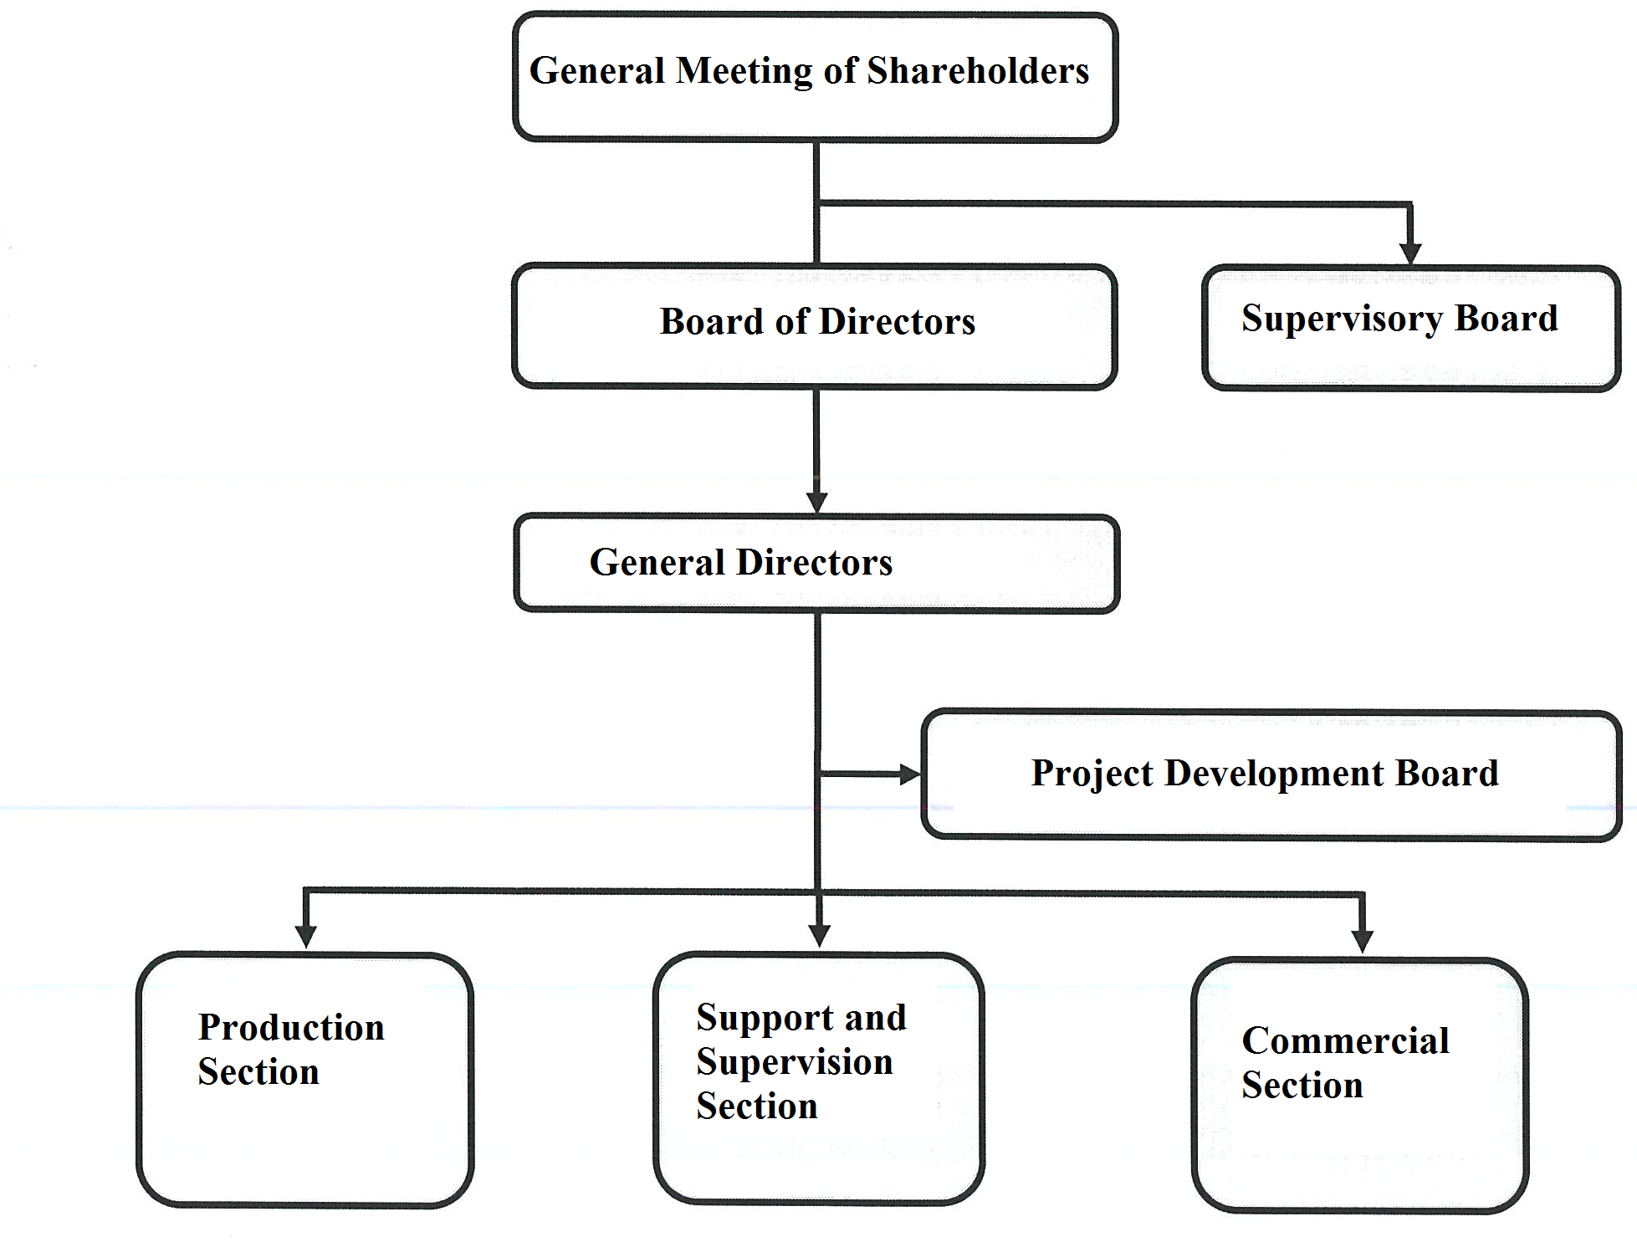
Article 10: Approve resignation of Mr. Nguyen Van Hoa and Ms. Doan Thi Thanh Huyen from position of member of Supervisory Board
Article 11: Approve resignation of Ms. Phung Thi Hai Ha from position of member of Board of Directors
Article 12: Approve appointment of additional members of Supervisory Board to replace Mr. Nguyen Van Hoa and Ms. Doan Thi Thanh Huyen for term of 2015 – 2020 as follows:
(i) Mr. Truong Van Bay
(ii) Mr. Vu Manh Tu
Article 13: Approve appointment of new member of Board of Directors: Mr. Le Van Nam to replace member of Board of Directors – Ms. Phung Thi Hai Ha for term of 2015 – 2020
Article 14: Approve assigning Board of Directors to choose an auditing company to audit financial statement 2018
Article 15: Approve remuneration for members of Board of Directors and Supervisory Board based on Statements of Board of Directors and Supervisory Board at the annual General Meeting of Shareholders
Board of Directors
Chairman of Board of Directors: monthly remuneration of Chairman of Board of Directors: 70% of monthly salary of General Director. In case of Chairman of Board of Directors cum General Director, besides salary for General Director, receiving remuneration for Chairman of Board of Directors: 70% of half of annual salary of General Director and appointing a Deputy Chairman of Board of Directors with remuneration of 70% of half of annual salary of General Director
- Member of Board of Directors: VND 3,000,000/ month
Supervisory Board
Head of Supervisory Board: VND 3,000,000/ month
Member of Supervisory Board: VND 2,000,000/ month
Article 16: With the aim of abiding by new laws on corporate governance, approving amendments and supplements to Charter of the Corporation as follows:
(i) Approve amendments and supplements to the Charter based on Statement on amendments and supplements to the Charter at the annual General Meeting of Shareholders 2018
(ii) Amendments and supplements to the Charter based on clause (i), which took effect from the date the annual General Meeting of Shareholders 2018 approved
(iii) Authorizing Chairman of Board of Directors to sign the issuing of the Charter
Article 17: In order to abide by new rules on corporate governance, issue of internal governance regulation
This General Mandate took effect from the signing date

